**AI PROJECT ON SURFACE AIR TEMPREATURE Monthly Mean**

**Team ID: PTID-AI-SEP22-1015**

**Project ID: PRAICP-1003-AirTempTS**

**Data Collection: Data Collected From DataMites**

**Surface air temperature is the temperature of the air around us, generally measured at a height of around two meters (about 6 and a half feet) above the surface. Thermometers, shielded from direct solar energy, are used to measure surface air temperature.**

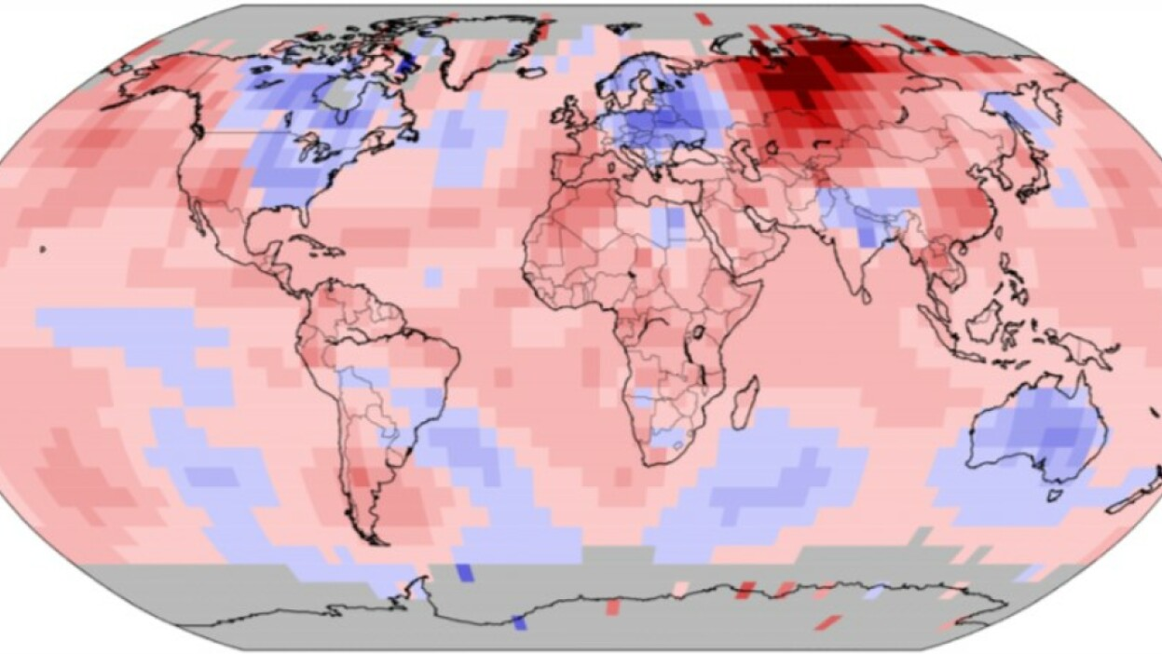

**PYTHON IMPLIMENTATION:**

* Load Data
* Check The Basics of data

**Visualise Trend of Surface Air Temperature:**

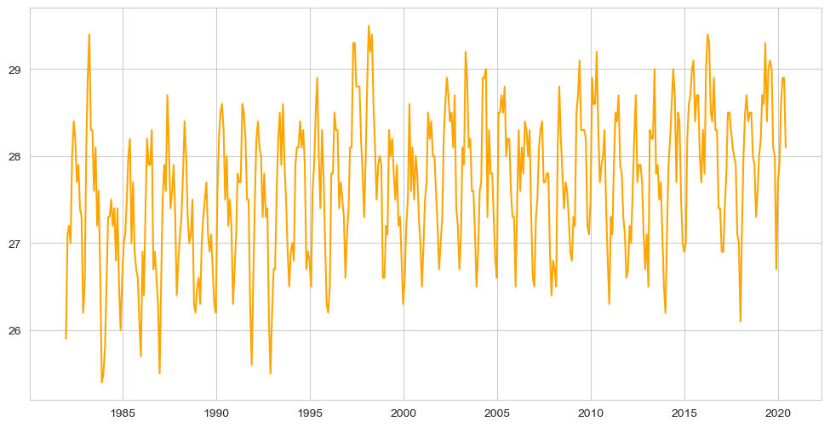

### Observation:

* The Data is shows the strong Seasonality.

**Visualise the different components like seasonal nature, trend for that we are use stats model**

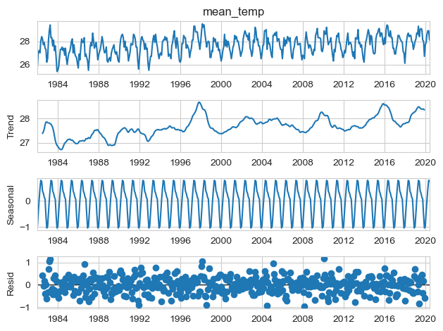

### Observation:

* In The Year of 1996 to 1998 surface air temperature has been suddenly increases.
* In 2014 to 2016 also surface temperature is high
* In This we can clearly see the seasonal pattern in data
* In Residule we can not explain the seasonal pattern and trend because of noise data.

# SPLIT DATA INTO TRAIN & TEST

* Taking last 12 month data for testing and remaining data for training

# SCALE DATA

* Scale the data using Min-Max scaler

**MODEL CREATION**

* In this project we are use LSTM to predict the mean of surface air temperature
* Creating a batches of 12 months with the help of timeseries generator
* Create sequential model
* Add LSTM layer with 100 neuron and the activation function is relu
* Add Output layer
* Check summary of model
  1. Total params: 40,901
  2. Trainable params: 40,901
  3. Non-trainable params: 0

**COMPILE & TRAIN MODEL**

* Use adam optimizer with loss of mean squared error
* Train model on 100 epoch to get a best result

**VISUALISE THE TRAINING LOSS**

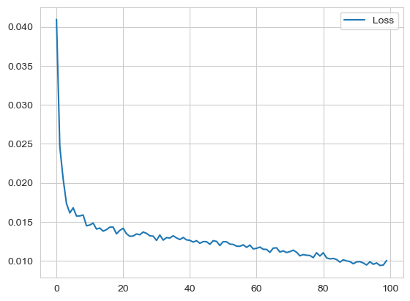

**MODEL SAVEING**

* Save trained model using .h5 extension

**PREDICTION**

* Take last 12 months values to make a prediction of first value of test set
* Reshape the data and make prediction

**CHALLENGES:**

* Problem Faced To Understand the Business case
* First time worked with time series data
* Problem faced to make prediction

**LEARNING FROM THIS PROJECT:**

* Learn time series prediction using LSTM
* Learn how to do monthly prediction.